Requirements and Specifications
Volume 2 - Specifications
This document outline is based on the IEEE Standard 1058.1-1987 for Software Project Management Plans.
This is the controlling document for managing a software project, and it defines the technical and managerial processes necessary to deliver the project requirements.
The paragraphs written in the “Comment” style are for the benefit of the person writing the document and should be removed before the document is finalized.
For
PGSuper
Version 1.3 - Draft
March 26, 1999
Richard Brice, PE
WSDOT
Richard Pickings, PE
BridgeSight Software
0000.doc
- Revision Chart
This chart contains a history of this document’s revisions. The entries below are provided solely for purposes of illustration. Entries should be deleted until the revision they refer to has actually been created.
The document itself should be stored in revision control, and a brief description of each version should be entered in the revision control system. That brief description can be repeated in this section. Revisions do not need to be described elsewhere in the document except inasmuch as they explain the development plan itself.

Version | Primary Author(s) | Description of Version | Date Completed
1.1 - Draft | RAB,RDP | Initial draft created for distribution and review comments | 6/26/98
1.1 - Final | RAB,RDP | Second draft incorporating initial review comments, distributed for final review | 7/17/98
1.2 - Final | RAB | Editorial changes | 10/7/98
1.3 - Draft | RDP | Updated specifications for handling and hauling | 2/1/99
 | RAB | Added requirements for prestress losses | 3/26/99

- Contents
New paragraphs formatted as Heading 1, Heading 2, and Heading 3 will be added to the table automatically. To update this table of contents in Microsoft Word, put the cursor anywhere in the table and press F9. If you want the table to be easy to maintain, do not change it manually.
1. Introduction
1.1 Document Organization
2. Functional Specifications
2.1 Bridge Modeling
2.1.1 Roadway Geometry
2.1.1.1 Roadway Alignment
2.1.2 Superstructure Modeling
2.1.2.1 General
2.1.2.2 Bridge Configuration
2.1.2.3 Girders
2.1.2.4 Diaphragms
2.1.2.5 Slab
2.1.3 Substructure Modeling
2.1.3.1 Abutments
2.1.3.2 Piers
2.1.4 Appurtenances
2.1.4.1 Traffic Barriers
2.1.4.2 Utilities
2.2 Analytical Modeling
2.2.1 Sign conventions
2.2.1.1 Beam Forces
2.2.1.2 Stresses
2.2.1.3 Reactions
2.2.1.4 Loads
2.2.1.5 Deflections
2.2.1.6 Section Properties
2.2.2 Points of Interest
2.2.2.1 Flavors of POI’s
2.2.2.2 Dual Nature of POI’s
2.2.2.3 Tolerancing Between POI’s
2.2.3 Section Properties
2.2.4 Loading
2.2.4.1 Self-weight of structural components and appurtenances
2.2.4.2 Wearing surface
2.2.4.3 Traffic Load
2.2.4.4 Distribution of Traffic Barrier Loads
2.2.4.5 Distribution of Utility Loads
2.2.5 Stage Analysis Models
2.2.5.1 Stressed Strands Stage
2.2.5.2 Prestress Release Stage
2.2.5.3 Initial Handling Stage
2.2.5.4 Hauling Stage
2.2.5.5 Deck Placement Stage
2.2.5.6 Superimposed Deadload Stage
2.2.5.7 In Service Stage
2.3 Prestress Losses
2.3.1 Assumptions
2.3.2 LRFD Refined Method
2.3.2.1 Instantaneous Losses
2.3.2.2 Time Dependent Losses
2.3.3 LRFD Approximate Lump Sum Method
2.3.3.1 Instantaneous Losses
2.3.3.2 Time Dependent Losses
2.3.4 General Lump Sum Loss Method
2.3.5 WSDOT Modified Rate of Creep Method
2.4 Specification Checking
2.4.1 AASHTO LRFD Bridge Design Specifications
2.4.2 Other Specifications
2.4.3 Check for Lifting In Casting Yard
2.4.3.1 Assumptions
2.4.3.2 Allowable Stress Check
2.4.3.3 Check for Cracking
2.4.3.4 Check for Ultimate Failure
2.4.3.5 Reduction in Factors of Safety for Inclined Cables
2.4.3.6 Prestress Losses
2.4.4 Check for Hauling to the Bridge Site
2.4.4.1 Assumptions
2.4.4.2 Allowable Stress Check
2.4.4.3 Check for Cracking
2.4.4.4 Check for Vehicle Rollover
2.5 Design
2.5.1 Design for Flexure
2.5.1.1 Selection of Prestressing Strands
2.5.1.2 Concrete Release Strength
2.5.2 Design for Shear
2.5.2.1 Design Algorithm
2.6 Materials
2.6.1 Standard Rebar
2.6.1.1 Rebar Material Properties
2.6.1.2 Bar Sizes
2.6.2 Prestressing Steel
2.7 Libraries
2.7.1 Library Data Items
2.7.1.1 Girders
2.7.1.2 Girder Connections
2.7.1.3 Traffic Barriers
2.7.1.4 Concrete
2.7.1.5 Specification
2.7.2 Location of Library Data File(s)
2.7.3 Library Data Synchronization
2.8 Reports
2.8.1 Paper Size and Format
2.8.2 Time and Date
3. User Interface Specifications
3.1 System Concept

- List of Figures
New figures that are given captions using the Caption paragraph style will be added to the table automatically. To update this table of contents in Microsoft Word, put the cursor anywhere in the table and press F9. If you want the table to be easy to maintain, do not change it manually.
This section can be deleted if the document contains no figures or if otherwise desired.
Figure 1 Schematic Roadway Alignment
Figure 2 - Girder Alignment Requirement
Figure 3 Generic I-Girder Cross Section
Figure 4 Diaphragm Length for Continuous Girders
Table 1 Intermediate Diaphragm Layout Rules
Figure 5 Generic Traffic Barrier Section
Figure 6 Sign Convention for Beam Forces
Figure 7 Dimensions for Hauling
Figure 8 WSDOT Shear Reinforcement Detailing Method
Figure 9 General Shear Zones in a Pre-cast Beam as Specified by LRFD
Figure 10 Proposed New WSDOT Shear Steel Detailing for Standard Girders
Table 2 Soft Metric Bar Sizes
Table 3 Grade 1725 (Grade 250) Strand Product Model Information
Table 4 Grade 1860 (Grade 270) Strand Product Model Information
Figure 11 Girder Dimensions
Table 5 WSDOT Standard Girder Sections (Dimensions in mm)
Table 6
Table 7
Table 8
Figure 12 Girder Connection Schematic
Figure 13

Introduction
This section should describe the purpose and background of the project and the organization of this document. No text is necessary between the heading above and the heading below unless otherwise desired.

Document Organization
List all of the major sections of the document, symbols, etc.
This document is the second of a three volume set that defines the requirements and specifications for the PGSuper program. This volume contains the detailed specifications for the application. This document is divided into two major sections; Functional Specifications and User Interface Specifications. The Functional Specifications section describes all the detailed information that must be accounted for in the application. The User Interface Specifications section, along with an operational prototype, detail the required look and feel of the user interface.
The other volumes in this documentation set are Volume 1 - Requirements, which provides the detailed requirements for the PGSuper program, and Volume 3 - Algorithm, which provides the specifications for the analysis and design algorithms that are to be used by the application.

Functional Specifications
This section describes detailed specifications of the system. Describe the user interface, documentation, interfaces with other systems. Provide discussion and diagrams showing the functional or object hierarchy of the system. Provide discussion and data flow/object diagrams of the basic processes in each major subsystem. Describe the general conventions used in the program (mathematical symbols, units of measure, etc.). For each basic function/object describe:
- Function name and number
- Input
- Process - detailed description of what the function should do
- Output
- Identification of candidate reusable software
- Acceptance criteria for verifying satisfaction of related requirements
- Data dictionary - indicating name of item, definition, structural composition of the item, item range, item type.

Bridge Modeling
This version of PGSuper will model slab-on-girder bridges as described in the Requirements document. Bridge Modeling consists of modeling of the Roadway Geometry, Superstructure Elements and Substructure elements. The subsections under this section will describe the bridge that PGSuper will model.

Roadway Geometry
PGSuper shall account for the effects of roadway geometry on the structure. Geometrical considerations shall include horizontal and vertical curves and crown slopes. Effects of the roadway geometry shall include effects on the geometry on bridge components and on the structural behavior of the bridge.

Roadway Alignment
The roadway alignment is divided into two parts, the horizontal alignment and the vertical alignment. Associated with the alignments is the roadway section which describes the roadway width, crown point offset, and superelevation data.
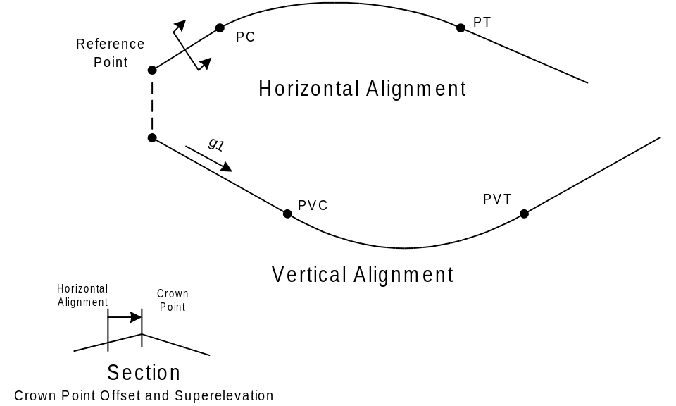
Figure 1 Schematic Roadway Alignment

Horizontal Alignment
The horizontal alignment describes the curvilinear path that the roadway follows. The path shall consist of a straight alignment at an arbitrary bearing or a single arbitrarily oriented circular curve. The reference point for the alignment shall be the a known station on a straight alignment or the point of curvature (PC) of a horizontal curve. The horizontal alignment need not represent the centerline of the roadway or bridge. Spiral curve segments are not support in this version of PGSuper.

Vertical Alignment
The vertical alignment describes the elevation profile of the horizontal alignment. The vertical alignment is linked to the horizontal alignment at the reference point. The vertical alignment defines the elevation of the reference point and either a straight grade or a vertical curve profile. Compound parabolic curves are not supported in this version of PGSuper.

Roadway Section
The roadway section is described by its width, crown point offset, and crown slopes.

Crown Point Offset
The crown point is the high point in the roadway surface. It is located left or right of the horizontal alignment and is constant throughout the alignment.

Crown Slopes
The crown slopes define the slope of the roadway surface. The slopes are measured to the left and the right of the crown point offset. Crown slopes shall be limited to ±0.10.

Superstructure Modeling

General
The following general requirements apply to the superstructure modeling.
- When present, the bridge must be entirely contained within a horizontal curve
- When present, the bridge must be entirely contained within a vertical curve
- All girders use the same concrete
- All girders use the same type of prestressing strands
- The same girder is used on all girder lines and in all spans
- The entire slab is made from one material
- The slab is a constant depth

Bridge Configuration
Slab-on-girder bridges can have any number of configurations. PGSuper will support the configurations described in this section.

Girderline Geometry
Girders in PGSuper must be straight in both plan and profile (ignoring camber). Girder lines need not be parallel. Girders must be aligned in each span such that each girder line is continuous over the entire length of the bridge. Girder centerlines must intersect at the pier centerline as shown in Figure 2 below.
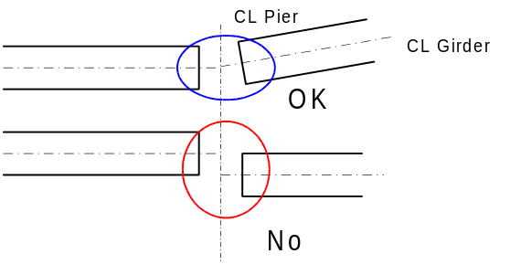
Figure 2 - Girder Alignment Requirement

Number of Girders Per Span
The bridge configuration will be limited to bridges with the same number of girders in every span. The minimum number of girders per span is 4. It is WSDOT practice to label prestressed girders A-Z. For this reason, the maximum number of girders per span is 26.

Girder Spacing
This section describes the specification for girder spacing.

Minimum Girder Spacing
The minimum girder spacing shall be the greater of 1100 mm or the top flange width of a girder.

Maximum Girder Spacing
There is not upper limit on girder spacing.

Spacing Types
Girder spacing shall be uniform at each pier and abutment. For a uniform spacing all girders are the same distance apart.

Measurement of Girder Spacing
Girder spacing is measured at the location and orientation described in this section.

Location of Measurement
Girder spacing will be measured at abutments and intermediate piers. At abutments, girder spacing will be measured at the centerline of bearing line. At intermediate piers, girder spacing will be measured at the centerline of the pier.

Direction of Measurement
Girder spacing can be measured normal to the roadway alignment or along the centerline of bearing or pier at abutments and piers, respectively.

Girder End Length
The end length of a girder is the distance from the centerline of bearing to the real end of the girder, measured normal to the centerline of bearing. This end length shall be limited to 900 mm.

Girders
In PGSuper, a girder is a real-life entity. We describe a girder with its product model. The product model completely describes the girder. The girder product model consists of the following attributes:
- Cross Section
- Harping Points
- Strand Pattern
- Strands
- Longitudinal Rebars
- Stirrups
- Associated Intermediate Diaphragm Type
- Concrete Material
- Strand Material
- Longitudinal Rebar Material
- Stirrup Material

Cross Section
This version of PGSuper will support only prismatic (e.g., no end blocks) I-shaped girders. The general shape of I girder cross sections is shown in Figure 3.
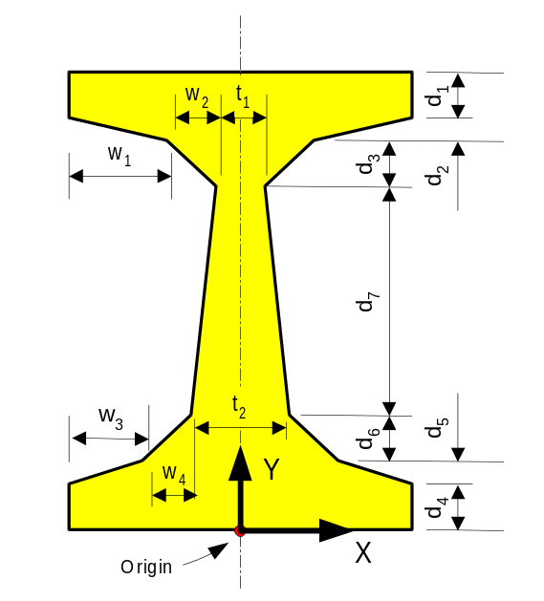
Figure 3
Generic I-Girder Cross Section

Harping Points
It is WSDOT practice to use harped strands to control stresses in the ends of precast girders. PGSuper supports the notion of harping points. A girder can have one or two harping points. In the case of one harping point the harping point is located at the center of the girder. In the case of two harping points, the harping points are placed symmetrically about the center of the girder.

Strand Pattern
For a given girder cross section, any number of strand configurations can be used. However, in practice, girder fabricators have expensive reusable forms that can only accept strands in predefined locations. PGSuper will support the notion of strand patterns that can be applied to a girder.

Types of Strand Patterns
Prestressed girders are reinforced with straight and/or harped strands. PGSuper will support the types of strand patterns defined in this section.

General
The information described in this section applies to all strand patterns.
- Strand patterns are described by their location along the length of a girder and by the location of individual strands within the pattern.
- Strand patterns must be symmetrical about the vertical axis of the girder cross section.
- Individual strand locations are described by an explicit coordinate and a fill sequence number.
- A strand pattern must define how many strands are added to the pattern at a time.
- Strand patterns can accept both ½” φ and 0.6” φ strands.

Straight Strand Pattern
Straight strand paths remain parallel to the girder line along the entire length of the girder. Hence, straight strand paths need only be described at one location along the girder. The explicit location of each strand is defined in cross-section coordinates. The maximum number of straight strands in a girder is limited to the number of strand in the straight strand pattern.

Harped Strand Pattern
Harped strand patterns are defined at the ends of the girder and at the harping point(s). The strand is assumed to follow a linear path between these points.
Two patterns are required to define harped strands. Harped strands must be defined at the ends of the girder and at the harping point(s). The maximum number of harped strands is equal to the number of strands described in the strand pattern at the end of the girder.
To control stresses in the girder, the harped strand patterns can be moved over the depth of the girder.

Harped Strand Pattern At End of Girder
Harped strands at the end of a girder are described by the location of each strand in the pattern and are measured in cross-section coordinates. The harped strand pattern at the end of the girder can be moved from its original location toward the bottom of the girder. The movement of the pattern is controlled by a movement increment and a maximum movement value.

Harped Strand Pattern At Harping Point
The location of strands at a harping point are defined in two strand bundles. The lower strand bundle is described by its location from the bottom of the girder and the maximum number of strands in the bundle. The upper strand bundle is described by its offset from the lower bundle. The upper bundle will contain all the strands that do not fit into the lower bundle. The movement of the pattern is controlled by a movement increment and a maximum movement value. The harped strand pattern at the harping point can be moved from its original location toward the top of the girder. The upper bundle is maintains its relative distance from the lower bundle. The bundles lie on the vertical axis of the girder.

Strands
The girder product model will contain a description of the strands used in a girder and the strand material product model.

Strand Usage
The product model will have the number of straight and harped strands used in the model. The model will also contain the harped strand pattern offset at the ends and harping points.

Strand Material
All prestressing strands will be of the same size and material.

Mild Steel Reinforcement In Girders
Mild steel reinforcement, consisting of horizontal rows of equally-spaced, same-sized, standard bars, may be defined anywhere in the girder cross section. Mild steel reinforcement rows are parallel to the girder line, run the entire length of the girder, and are symmetrical about the vertical axis of the girder. Mild reinforcement rows are placed by specifying the following data:
- Bar size
- Reinforcing Material
- Girder Face (Top or Bottom)
- Distance to center of bar row measured from face specified in #3
- Number of bars
- Bar Spacing.

Shear Reinforcement
Shear reinforcement in PGSuper consists of vertically-oriented stirrups made from standard rebars at equal spacing in non-overlapping zones defined along the length of the girder. Stirrup zones must be symmetric about the girder mid-span. Stirrups will have 2 legs. Shear reinforcement zones are placed by specifying the following data:
- Distance from end of girder to start of first zone
- Reinforcing Material
- Length of the zone
- Bar size in the zone
- Number of bars (1 or 2) in the zone
- Stirrup Spacing.
At the user’s discretion, the last stirrup zone may be extended such that the mid-section of the girder contains stirrups.

Associated Intermediate Diaphragms
The bridge product model has an intermediate diaphragm layout scheme as described in Section 2.1.2.4.5. This scheme defines how many and where intermediate diaphragms are used in the bridge model. Associated with each girder is an intermediate diaphragm that defines what the cross section of the diaphragm will be.

Concrete Material
The concrete models used for girder and slab concrete are described by concrete material product models. Associated with a girder is its concrete product model and the release strength of the concrete.

Mild Reinforcmenet Material
The mild reinforcing steel used for longitudinal bars and stirrups is defined by a product model. The girder has an association with this product model.

Diaphragms
PGSuper will account for the presence of diaphragms at the ends of spans as well as diaphragms within the spans. Diaphragms will be modeled for the purpose of self-weight calculations and calculation of live load distribution factors (See LRFD 4.6.2.2.2d).

Cross Section
Diaphragms will be modeled as having a rectangular cross section and will be prismatic between girders. The depth of an intermediate diaphragm is limited to that of the girder. The maximum width of an intermediate diaphragm is 610 mm. The maximum width of an end diaphragm is 1200 mm.

Diaphragms at Abutments
This section describes the length of diaphragms at abutments

Wall Abutments
For wall type abutments, diaphragms will be considered attached to the ends of the girder with the same width as the bridge deck. (See BDM Section 6.2-A. Typically used with girder end type A)

Seat Abutments
For seat type abutments, diaphragms will be considered to be placed between girders and will be the length of the girder spacing less half the width of the adjacent girders. (See BDM Section 6.2-A. Typically used with girder end type B)

Diaphragms at Interior Piers
This section describes the length of diaphragms at intermediate piers

Continuous Girder Connection
For continuous girders at interior piers, the length of the diaphragms will be taken as the distance between the exterior girders, as shown in Figure 4 below. (See BDM Section 6.2-A. Typically used with girder end type C)
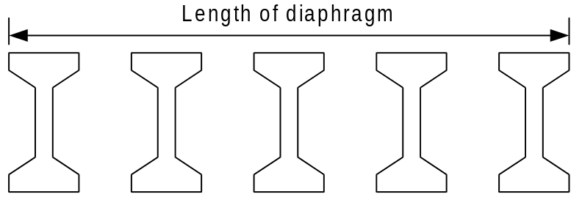
Figure 4 Diaphragm Length for Continuous Girders

Expansion Joint Connection
For piers where the girders are simply supported and form an expansion joint, the diaphragms will be the same as for seat abutments.

Intermediate Diaphragms
Intermediate diaphragms will be considered to be placed between girders and will be the length of the girder spacing less half the width of the adjacent girders. (See BDM Section 6.2-A for standard details)

Layout of Intermediate Diaphragms
Intermediate diaphragms will be laid out according to a set of rules as described in the table below.
Table 1 Intermediate Diaphragm Layout Rules
 | Bearing to Bearing Span Length | Number of Intermediate Diaphragms
 | Less than L1 | N1
ý | L1 to L2 | N2
ý | L2 to L3 | N3
ý | L3 to L4 | N4
 | Greater than or equal to L4 | N5
The check boxes indicate optional rules. The starting length of enabled rule N is always the ending length of the of the enabled rule N-1.

Slab
The PGSuper bridge model supports slabs of uniform thickness whose edges are parallel the exterior girders. The bottom of the slab is offset from the top of the girder by a haunch depth. A haunch depth is defined at the point where the centerline of the girder and the bearing line intersect in plan view and at mid-girder.

Slab Depth
The slab depth will be uniform. The slab depth is measured normal to the roadway surface. If a sacrificial depth is used as a wearing surface, the sacrificial depth is included in the slab depth input by the user. The slab depth shall not be greater than 610mm.

Slab Haunch
The slab haunch will be modeled by the “A” dimension and a minimum haunch depth at mid span (typically ¾”). The haunch width is assumed to be the same as the width of the top flange of the girder.

Slab Material
The slab will be constructed of a single material. The product model of the concrete material will be referenced by the slab product model.

Wearing Surfaces
A slab is covered with a wearing surface. The wearing surface will be accounted for in weight calculations, but will not be considered for the strength of the bridge. The wearing surface can be a sacrificial slab depth and/or an asphalt overlay.

Sacrificial Wearing Surface
A sacrificial wearing surface is a portion of the top of the roadway slab that is expected to be worn down over time. The sacrificial wearing surface is described by a sacrificial depth of slab. The depth of the sacrificial wearing surface shall not exceed one half of the slab depth.

Asphalt Overlay
The slab is often overlaid with asphalt or other surfacing. This surfacing treatment contributes weight, but not strength to the structure. The overlay wearing surface is described by its depth and its unit weight. It is assumed that the overlay will be placed over the entire slab surface between traffic barriers.

Substructure Modeling
The focus of PGSuper is on the modeling, design, and analysis of slab-on-girder, prestressed girder bridges. However, the superstructure does not exist without the substructure. For this reason, some minimal substructure modeling is required. Substructure elements will be modeled in such a way that they capture the super to substructure connectivity and any influence the substructure may have on the overall behavior of the structure.

Abutments

Abutment Types
PGSuper will model both wall and seat type abutments.

Abutment Geometry
The geometry of an abutment is defined by its location and orientation.

Abutment Location
The location of an abutment will be defined by the station of the back of pavement seat.

Abutment Orientation
The orientation can be normal to the alignment, defined by a skew angle, or at a given bearing.

Piers
The modeling of piers is not included in this version of PGSuper.

Appurtenances
This section specifies how appurtenances to the bridge structure are to be modeled.

Traffic Barriers
The cross section of the traffic barrier will be as shown in Figure 5.
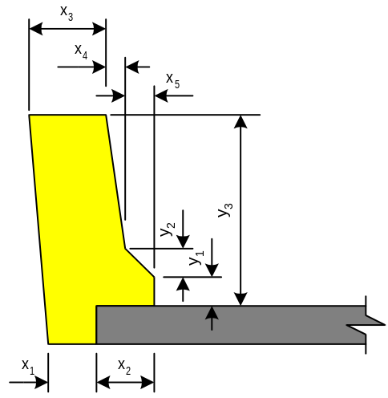
Figure 5 Generic Traffic Barrier Section

Utilities
Utilities shall be modeled as a uniform weight applied over the entire length of the bridge structure.

Analytical Modeling
PGSuper obtains its analytical results, such as shears, moments, and reactions, using analytical models. These models provide a mathematical representation of the structure and are used to capture its response and behavior.

Sign conventions
This section describes the sign conventions used in the analysis.

Beam Forces
PGSuper uses beam sign conventions for beam shear and moments. Axial tension in the beam is positive. Positive shear, moment, and axial force are as shown in Figure 6.
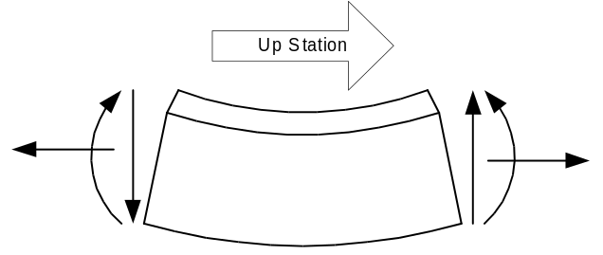
Figure 6 Sign Convention for Beam Forces

Stresses
A tensile stress is positive.

Reactions
Upward reaction forces are positive.

Loads
Externally applied loads are positive if they have a downward sense.

Deflections
Downward deflections are positive. Counterclockwise rotations (right-hand rule) are positive.

Section Properties

Section Coordinates
The X axis will be the horizontal axis and increase from left to right when looking up-station. The Y axis is the vertical axis and will increase upward. The origin of the section coordinate system is at the bottom of the cross section.

Area and Moment of Inertia
Area and moment of inertial are also positive values.

Section Modulus
Section modulus are greater than zero for the bottom of the section and less than zero for the top of the section.

Eccentricity
Eccentricities are greater than zero when below the centroid of the section

Centroid
The location of the centroid is also represented with positive distances.

First Moment of Area (Q)
The first moment of area of the slab, Q, is always positive.

Kern Points
The bottom kern point is greater than zero the top kern point is less than zero.

Points of Interest
It is the nature of digital computer calculations that we can only analyze a structure at discrete locations. The placement of these analysis points, or Points of Interest (POI’s) is critical to the accuracy, and ultimate success, of the analysis. The AASHTO LRFD manual recommends analyzing girders at 1/10th points, and then also specifies other critical analysis locations for given analysis quantities.
PGSuper shall supports points of interest at 1/10th points, harping points, and the critical section for shear.

Flavors of POI’s
PGSuper shall have several “flavors” of POIs for reporting. POIs shall be designated for flexure, shear, and handling. When reporting results for flexure, only flexure POIs are used, for shear, use shear POIs, etc.

Dual Nature of POI’s
Analysis quantities such as shear response can exhibit discontinuous jumps at any location. Hence, POI results must be able to support dual results at locations where this type of behavior occurs.

Tolerancing Between POI’s
The program uses a tolerance of 5mm between POI’s. In other words, if two POI’s are closer than 5mm, they are merged together into a single POI.

Section Properties
Composite and non-composite section properties will be computed. The effect of the slab haunch will be ignored for composite section properties. That is, it will be assumed that the bottom of the slab rests of the top of the girder at all locations.

Loading
PGSuper will accommodate the loading types defined in this section

Self-weight of structural components and appurtenances
These loads will be internally calculated by the program using data from program libraries and user input.

Wearing surface
Wearing surface loads are uniform loads specified by the thickness of the wearing surface and the density of the surfacing material.

Traffic Load
Traffic loads shall be applied per the LRFD Specifications.

Distribution of Traffic Barrier Loads
Traffic barrier loads shall be distributed over one or more external girders. The default value for WSDOT shall be 3. This parameter shall be variable and can be set by the user.

Distribution of Utility Loads
Utility loads shall be distributed over one or more external girders. The default value for WSDOT shall be 3. This parameter shall be variable and can be set by the user.

Stage Analysis Models
It is the nature of precast prestressed girder bridge construction that the bridge is built is stages. At each of these stages different structural behaviors are exhibited. The girder and bridge structure is also different in each of these stages. PGSuper will use a variety of analysis models to account for the changes in the bridge structure over time.

Stressed Strands Stage
The strands have been placed into the casting bed and stressed. The girder concrete has not been placed yet.

Purpose
The purpose of this model is for establishing the basis for the prestress force as it degrades over time due to losses and to perform a specification check on the strands.

Prestress Release Stage
Precast girder in the casting yard immediately after the removal of all forms and the release of the prestress force to the girder.

Purpose
This model is used to determine the stresses in the girder.

Depends On
The prestress force in this model depends on the strand forces from the Stressed Strands Stage model and prestress losses due to elastic shortening and initial relaxation.

Span Length
The end to end length of the girder is used for the span length.

Boundary Conditions
Girder ends are simply supported.

Section Properties
Non-composite section properties are used.

Loads
Self weight of the girder is the only external load for this model.

Initial Handling Stage
The girder has been removed from the casting bed and is being transported to a storage area where it will cure and achieve its 28 day strength.

Purpose
The purpose of analysis at this stage is to determine the stresses during handling and to assure the girder is stable.

Depends On
The prestress forces in this stage depend upon the cumulated losses to this point in time. The girder strength is assumed to be the release strength.

Span Length
The span length is the length between lifting devices. The cantilever ends shall be considered in the analysis.

Section Properties
Non-composite section properties shall be used for this analysis.

Loads
The loads for this analysis include the girder self-weight and impact factors.

Hauling Stage
The girder is placed on a truck for hauling to the bridge site.

Purpose
The purpose of this model is to determine the stresses in the girder during transportation and to evaluate the girders stability.

Depends On
This model only depends on the cumulative prestress losses.

Span Length
The span length is the length between hold down devices on the truck. The cantilever ends shall be considered in the analysis.

Section Properties
Non-composite section properties shall be used in this analysis.

Loads
The loads for this analysis include the girder self-weight and impact factors.

Deck Placement Stage
Girders are in place at the bridge site supported by the abutments and piers. The girders are supporting form work and the wet slab and diaphragms. (AKA Bridge Sight Stage 1)

Purpose
The purpose of this model is to determine the moments, shears, reactions, deflections, and girder stresses for this critical stage of the non-composite girder section.

Depends On
This model only depends on the cumulative prestress losses.
It shall be assumed that all prestress losses have occurred prior to this stage.

Span Length
The bearing to bearing span length is used for this model.

Boundary Conditions
The girders are simply supported for this model. Cantilever ends are considered for end diaphragms.

Section Properties
Non-composite girder properties are used in this model.

Loads
This model considers the self-weight of the girders, weight of form work, wet slab and diaphragms, and any user defined loads applied in this stage.

Superimposed Deadload Stage
The bridge deck has been placed and allowed to achieve its 28 day strength. Superimposed dead loads such as traffic barriers and overlays are added to the structure. (AKA Bridge Sight Stage 2)

Purpose
The purpose of this model is to determine the moments, shears, reactions, deflections, and girder stresses for this stage of the girders life.

Depends On
This model depends on the results of the Deck Placement Stage model.

Span Length
The bearing to bearing span length is used in this model for simple span modeling situations. For continuous span modeling situations, the bearing point for the continuous girder ends is used.

Boundary Conditions
The same boundary as the Deck Placement Stage model are used.

Section Properties
Composite section properties are used in this model.

Loads
The loads introduced in this model are the weight of the traffic barrier, utilities, and wearing surface overlays.

In Service Stage
The bridge is complete and open to traffic. (AKA Bridge Site 3)

Purpose
The purpose of this model is to determine the moments, shears, reactions, deflections, and girder stresses for this stage of the girders life.

Depends On
This model depends on the results of the Superimposed Deadload Stage.

Span Length
The same span lengths as the Superimposed Deadload Stage model are used.

Boundary Conditions
The same boundary as the Superimposed Deadload Stage model are used.

Section Properties
The same section properties as the Superimposed Deadload Stage model are used.

Loads
The loads introduced in this model are the vehicular live loads.

Prestress Losses
PGSuper shall accommodate the calculation of prestress losses using the following methods:
- LRFD Refined Method
- LRFD Approximate Lump Sum Method
- General Lump Sum Method
- WSDOT Modified Rate of Creep Method
The applicability of a given loss calculation method shall be verified before it is used. In the event the method is not applicable, the user must be notified and the method must not be used.

Assumptions
It will be assumed that all losses occur prior to the placement of the roadway slab.

LRFD Refined Method
Losses will be computed as instantaneous and time dependent losses.

Instantaneous Losses
Instantaneous losses shall be computed in accordance with LRFD Article 5.9.5.2.3a.

Time Dependent Losses
Time dependent losses shall be computed in accordance with LRFD 5.9.5.4. The parameter f_{pj} defined in Article 5.9.5.4.4b shall be taken as the jacking stress rather than the tendon stress at the end of stressing.

LRFD Approximate Lump Sum Method
Losses will be computed as instantaneous and time dependent losses.

Instantaneous Losses
Instantaneous losses shall be computed in accordance with LRFD Article 5.9.5.2.3a.

Time Dependent Losses
Time dependent losses shall be computed in accordance with LRFD 5.9.5.3. This method of loss calculation shall be extended to include concrete that is cured by radiant heat, stress-relieved strands, and structures in corrosive exposure conditions.

General Lump Sum Loss Method
For this method of determining losses, the user will simply enter losses for the following stages: Before prestress transfer, after prestress transfer, at lifting, at shipping, and final.

WSDOT Modified Rate of Creep Method
TBD - This method is still under development by the Bridge and Structures Office

Specification Checking
PGSuper is primarily a specification checking program. Its main purpose is to evaluate a precast girder against of set of criteria. The criteria is mostly derived from the AASHTO LRFD Bridge Design Specification, however other criteria such as geometric constraints and local practice are checked as well. This section will detail the checks that the PGSuper program will and will not perform. A detailed specification check flowchart can be found in the associated “Check Flowcharts.vsd” file.

AASHTO LRFD Bridge Design Specifications
TBD

Other Specifications
TBD

Check for Lifting In Casting Yard
The goal of checking for lifting is to confirm that a girder can be safely supported by lifting loops during handling at the casting yard immediately after the concrete’s release strength has been obtained. Lifting loop locations are user-specified and are symmetrical about mid-span.
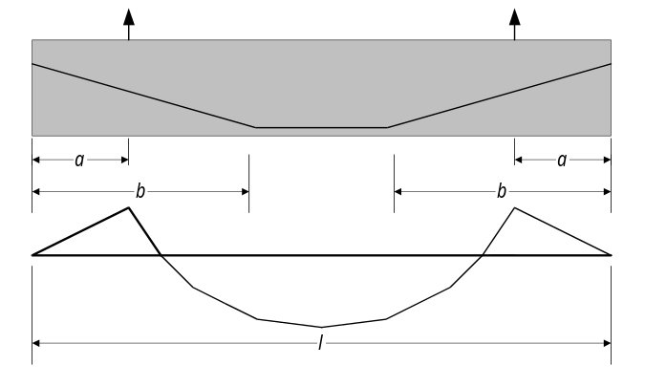

Assumptions
- Lifting points are located outboard of harping points

Allowable Stress Check
Allowable tensile and compressive stresses are to be checked at the lifting points, harping points, and tenth points along the length of the girder.

Allowable Tensile Concrete Stress
The maximum allowable tensile stress in the girder concrete is defined as:
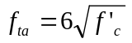in psi
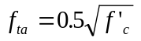in MPa

Allowable Compressive Concrete Stress
The maximum allowable compressive stress during lifting in the girder concrete is defined as:
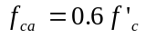

Check for Cracking
The check for cracking is in the form of a factor of safety. Cracking is checked only at the top flanges at the harping points. ß is this right? It seems to me that cracking could occur in the bottom flange or at other locations along the beam depending on the prestressing configuration and the actual shape of the generic I-beam cross section we use. The equation for the factor of safety against cracking for a hanging beam is as follows:
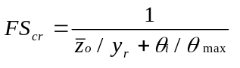 ≥ 1.0
where:
z_{o} is the theoretical lateral deflection of the center of gravity of beam with full dead weight applied laterally. Given as:
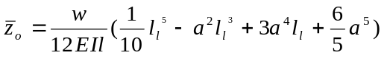 where:
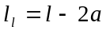 = the distance between lifting points
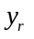 is the height of the roll axis above the center of gravity of the hanging beam given as:
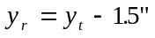
or, alternatively as:
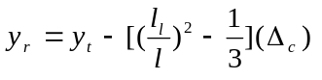 where:
y_{t} = vertical distance from top of girder to center of gravity
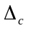= total upward camber deflection given as:
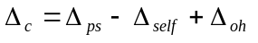 where:
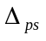= upward deflection over length due to prestress
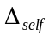= downward deflection over length due to self weight
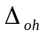= upward deflection over length due to overhangs
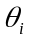is the initial roll angle of a rigid beam. Defined as:
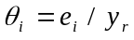 where:
= initial lateral eccentricity. Given as:
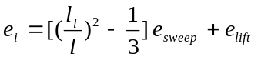 where:
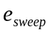= ½ of PCI sweep = 1/16” per 10’ of total length
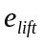= lifting loop placement tolerance = 0.25 inch
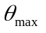is the tilt angle at which cracking begins. Given as:
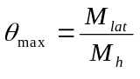 where:
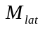= lateral bending moment at cracking at harping point. Defined as:
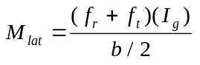 where:
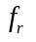= tensile rupture stress of concrete defined as:
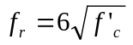in psi
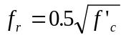in MPa

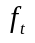= stress in top flange at harping point due to prestress and self-weight
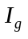= gross moment of inertia of girder at harping point
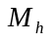= self-weight bending moment of beam at harping point.

Check for Ultimate Failure
The factor of safety against ultimate failure of the girder during lifting must also be checked. This analysis takes into account the reduced stiffness due to cracking of the beam. The factor of safety for ultimate failure is checked at the harping points only, and is defined as:
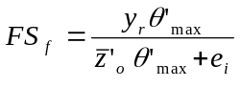 ≥1.5, where:
is the height of the roll axis above the center of gravity of the hanging beam as defined in Section 2.4.3.3
= initial lateral eccentricity from Section 2.4.3.3
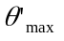is the tilt angle at maximum factor of safety against failure. Defined as:
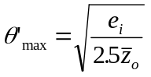 where:
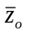= theoretical lateral deflection of the center of gravity of beam with full dead weight applied laterally. Taken from Section 2.4.3.3
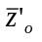is the theoretical lateral deflection of the center of gravity of beam with full dead weight applied laterally, computed using 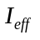for the tilt angle .
If the factor of safety against cracking (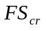) is satisfied, but the factor of safety against failure (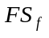) is not satisfied, the stability of the girder may be considered adequate. ßWhy bother checking failure?

Reduction in Factors of Safety for Inclined Cables
Inclined lifting cables will introduce added compressive forces into the girder at lifting time. If extreme lifting angles are used, this can give rise to global buckling. However, WSDOT policy is to use spreader bars or multiple cranes to alleviate this problem. Hence, this effect will not be considered by the PGSuper program.

Prestress Losses
A lump-sum total prestress loss of 20 ksi shall be used for the lifting analysis.

Check for Hauling to the Bridge Site
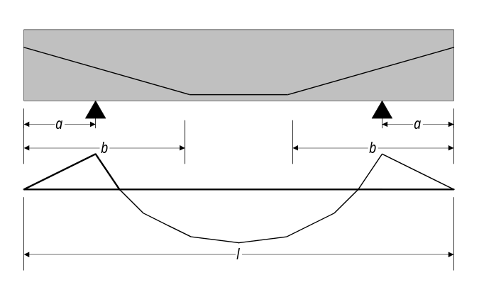
Figure 7
Dimensions for Hauling
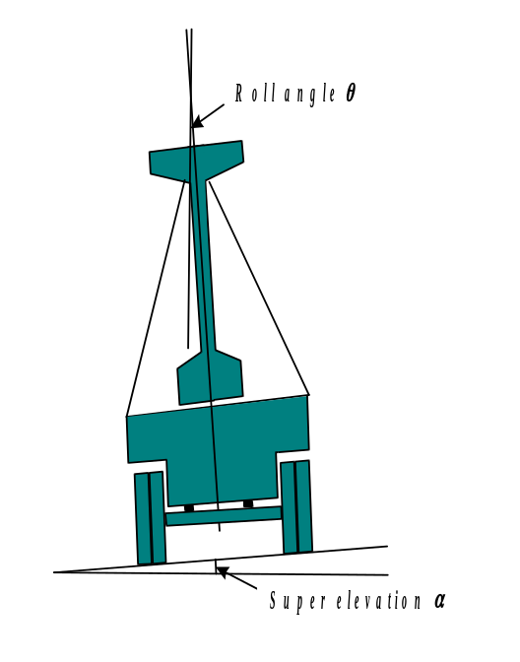
The goal of designing for hauling is to confirm that a girder may be safely supported on its bottom flange during transportation. Support locations are user-specified and are symmetrical about mid-span.

Assumptions
- Support points are located outboard of harping points

Allowable Stress Check
Allowable tensile and compressive stresses are to be checked at the support points, harping points, and tenth points along the length of the girder.

Allowable Tensile Concrete Stress
The maximum allowable tensile stress in the girder concrete during hauling is defined as:
in psi
in MPa

Allowable Compressive Concrete Stress
The maximum allowable compressive stress during hauling in the girder concrete is defined as:

Check for Cracking
The check for cracking during hauling is in the form of a factor of safety. Cracking is checked only at the top and bottom flanges at the harping and support points. The equation for the factor of safety against cracking for a beam supported from below is as follows:
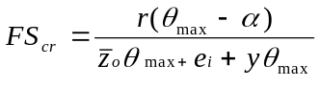 ≥ 1.0
where:
is the radius of stability for the truck/girder system = 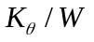
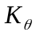= rotational spring constant for vehicle. A value of 40,500 in-kip/rad may be used if field test data is not available.
= total weight of beam
is the tilt angle at which cracking begins as defined in Section 2.4.3.3.
= maximum expected superelevation angle the vehicle is expected to encounter on the way to the job site. A minimum of .06 shall be used.
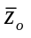 is the theoretical lateral deflection of the center of gravity of beam with full dead weight applied laterally as defined in Section 2.4.3.3.
= the initial lateral eccentricity between the center of gravity of the beam and the roll center of the truck. Given as:
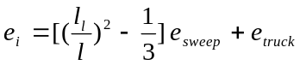 where:
=PCI sweep = 1/8” per 10’ of total length
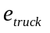= beam placement tolerance = 1.0 inch

is the height of the center of gravity of the beam above the vehicle roll axis. This value shall be increased by 2% to account for beam camber effects.

Check for Vehicle Rollover
The factor of safety against rollover of the vehicle during hauling must also be checked. The factor of safety for ultimate is defined as:
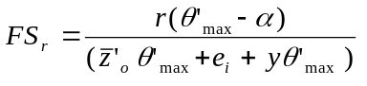 ≥1.0 Where:
is the radius of stability for the truck/girder system as defined in Section 2.4.4.3
= initial lateral eccentricity from Section 2.4.4.3
is the tilt angle at maximum factor of safety against failure. Defined as:
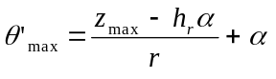 where:
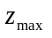= distance from centerline of vehicle to center of dual tires.
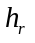= height of vehicle roll center above road.
is the height of the center of gravity of the beam above the vehicle roll axis as defined in Section 2.4.4.3

Losses
A lump-sum total prestress loss of 35 ksi shall be used for the Hauling analysis.

Design
While PGSuper is primarily a specification checking program it has a design capability. The purpose of the design feature is to compute unknown input variables for a specification check. The design process consists of design for flexure and design for shear. Each of these design activities are described in this section. A detailed design flowchart can be found in the associated “Design Flowcharts.vsd” file.

Design for Flexure
The goal of flexural design is to determine the number and configuration of prestressing strands and the minimum release strength for the girder concrete.

Selection of Prestressing Strands
Strands will be selected such that the maximum number of straight strands and the minimum number of harped strands will be used, such that the stress criteria are satisfied. The harped strand pattern may be adjusted to control stresses.

Concrete Release Strength
The concrete release strength will be the least concrete strength required to satisfy the stress criteria in the casting yard stage. The release strength shall not be less than 5000 psi and shall not be more than 7200 psi or 90% of the 28 day strength, which ever is less. See flow chart 1.3.1 for details.

Design for Shear
Figure 8 shows a schematic of the shear design as currently used by WSDOT. The current WSDOT design software determines the design variables S and LS. This may be compared to LRFD as shown in Figure 9. The LRFD method differs significantly from current WSDOT practice because the location of the critical section is a variable which depends on loading information for a specific girder installation. The location of the critical section was previously assumed to be around d/2 from the face of the support. Review of the two Figures reveals that the new LRFD results are significantly and fundamentally different from existing methods based on the older Specifications. A new design philosophy will have to be employed.
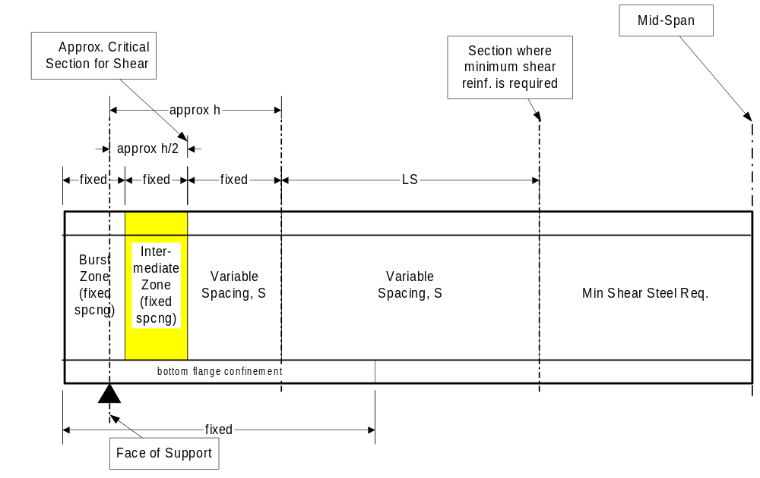
Figure 8 WSDOT Shear Reinforcement Detailing Method
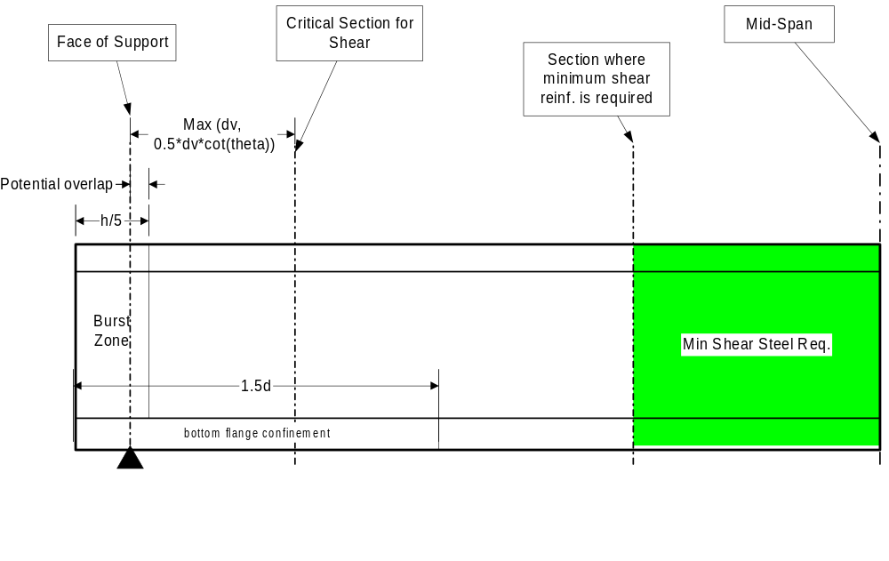
Figure 9 General Shear Zones in a Pre-cast Beam as Specified by LRFD

Design Algorithm
PGSuper will support two methods of shear design. Both of the methods are exactly the same, except for the stirrup detailing algorithms. The first method will be known as the fixed design method and the second method will be known as the standard design method. Each method is described in the following sections. The basic design algorithm is as follows:
- Design for vertical shear. Determine A_{v}/S.
- Design for horizontal shear. Determine A_{vf}/S.
- Design for bursting zone requirements.
- Design for confinement requirements.
- Detail stirrups.

Fixed Design Method
In the fixed design method, a predefined, fixed stirrup design is used. The same stirrup detailing is used for every girder of a given type. This method will be the WSDOT standard of practice.

Standard Design Method
In the standard design method a simple algorithm will be used to detail the stirrups as shown in Figure 10.
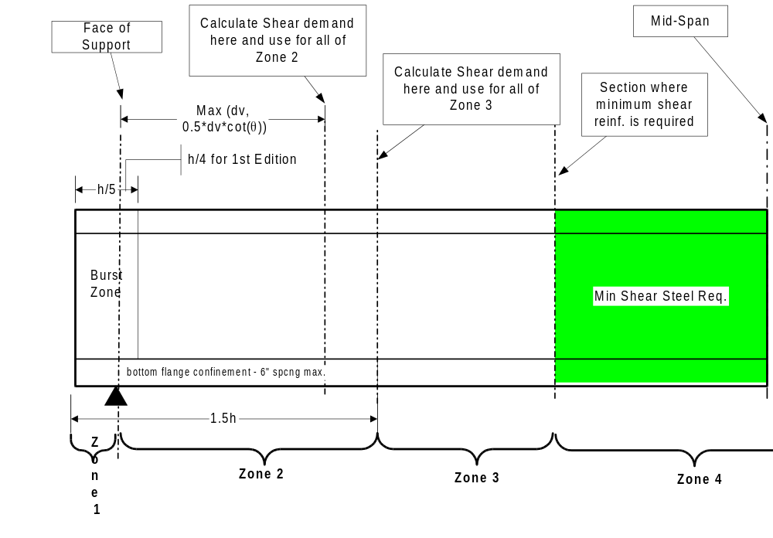
Figure 10
Proposed New WSDOT Shear Steel Detailing for Standard Girders

Materials
This section describes materials used in PGSuper

Standard Rebar
This section describes the rebar material used for longitudinal reinforcement and shear reinforcement.

Rebar Material Properties
The following material properties are defined for rebar in PGSuper.

Yield Strength
The rebar yield strength shall be 410MPa.

Modulus of elasticity
The modulus of elasticity shall be 200 000 MPa.

Ultimate tensile strain
The ultimate tensile strain shall be 0.008.

Bar Sizes
PGSuper will supply a library containing the bar sizes in the following tables. Standard US bar sizes and ‘soft-metric’ bar sizes will be supported in the library.
Table 2
Soft Metric Bar Sizes
Bar Sizes - Soft Metric
Bar  Designation | Nominal Diameter | Cross  Sectional  Area
No. | mm (in) | mm² (in²)
10M (#3) | 9.5 (0.375) | 71 (0.11)
13M (#4) | 12.7 (0.500) | 127 (0.20)
16M (#5) | 15.9 (0.625) | 198 (0.31)
19M (#6) | 19.1 (0.750) | 285 (0.44)
22M (#7) | 22.2 (0.875) | 388 (0.60)
25M (#8) | 25.4 (1.000) | 507 (0.79)
29M (#9) | 28.6 (1.125) | 641 (1.00)
32M (#10) | 32.3 (1.270) | 817 (1.27)
36M (#11) | 35.8 (1.410) | 1007 (1.56)
43M (#14) | 43.0 (1.693) | 1452 (2.25)
57M (#18) | 57.3 (2.257) | 2581 (4.00)

Prestressing Steel
Table 3 Grade 1725 (Grade 250) Strand Product Model Information
Grade 1725 (Grade 250)
Nominal Diameter  mm (in) | Nominal Area  mm² (in²)
6.35 (0.25) | 23.22 (0.036)
7.94 (0.313) | 37.42 (0.058)
9.53 (0.375) | 51.61 (0.080)
11.11 (0.438) | 69.68 (0.108)
12.70 (0.500) | 92.90 (0.144)
15.24 (0.600) | 139.35 (0.216)
Table 4 Grade 1860 (Grade 270) Strand Product Model Information

Grade 1860 (Grade 270)
Nominal Diameter  mm (in) | Nominal Area  mm² (in²)
9.53 (0.375) | 54.84 (0.085)
11.11 (0.438) | 74.19 (0.115)
12.70 (0.500) | 98.71 (0.153)
15.24 (0.600) | 140.00 (0.217)

Libraries

Library Data Items
This section defines the data items that are to be stored with each library entry of the given type. Each entry in a library can be identified by a unique name string.

Girders
- Section shape
- Straight and harp strand templates
- Harping point location (defined by ratio along span)
- Diaphragm size(s) and location(s)
- Stirrup Detailing Method
- Longitudinal Reinforcement

Section Shape
PGSuper will not have any built-in I-girder shapes. All girder shapes will be contained in a girder library as described below. The default girder library will have the standard WSDOT girder shapes pre-stored.
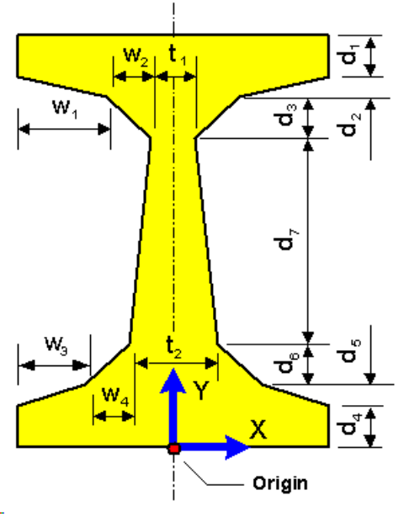
Figure 11
Girder Dimensions

WSDOT Standard Girders
PGSuper will support the following WSDOT Standard Girders
Girder | W₁ | W₂ | W₃ | W₄ | D₁ | D₂ | D₃ | D₄ | D₅ | D₆ | D₇ | T₁ | T₂
W42G
W50G
W58G
W74G
W21G
W24G
Table 5 WSDOT Standard Girder Sections (Dimensions in mm)

Strand Patterns
TBD

WSDOT Standard Girders
TBD

Harping Points Locations
TBD

WSDOT Standard Girders
Harping points will be at the locations indicated for the WSDOT Standard Girders
Table 6
Girder | Fraction of Girder Length
W42G | 0.333
W50G | 0.400
W58G | 0.400
W74G | 0.400
W21G | 0.400
W24G | 0.400

Diaphragm
TBD

WSDOT Standard Girders
The following diaphragms will be used for the WSDOT Standard Girders
Table 7
Girder | Width (mm) | Height (mm)
W42G
W50G
W58G
W74G
W21G
W24G

Stirrup Detailing Method
The stirrup detailing method can be Automatic or Fixed. For the Automatic method, no library input is required. For the Fixed method, fully detailed stirrups are provided with the girder.

WSDOT Standard Girders
The following fixed method data will be associated with the WSDOT Standard Girders
Table 8
TBD | TBD
TBD | TBD

Girder Connections
Girder Connections describe the end size of the girder, the bearing offset, and the end diaphragm. A connection has an associated usage type. The usage type indicates if the connection can be used at abutments, piers, or both.

Girder End Distance
The girder end distance is the distance from the bearing point to the end of the girder. This distance is specified for situations where a girder is used as an interior or an exterior girder (See WSDOT Standard Girder plans, End Type B). The end distance may be measured in the same direction as a tangent to the alignment at the point of bearing, normal to the pier or abutment, or along the projected centerline of the girder.

Bearing Offset
The bearing offset is the distance from the pier or abutment reference line to the point of bearing on the girder. This distance shall be measured normal to the pier or abutment.
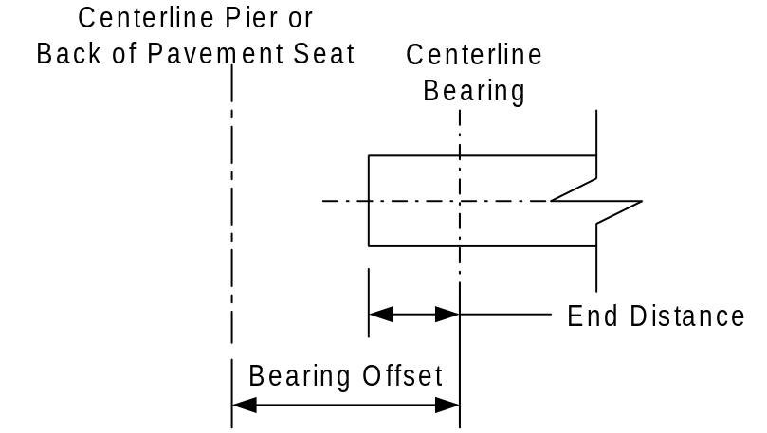
Figure 12 Girder Connection Schematic

End Diaphragm
The end diaphragm is modeled as described in Section 2.1.2.4.1 of this document.

Traffic Barriers
The traffic barrier library contains named traffic barriers and the dimensions of the general traffic barrier section shown in Figure 5.

Concrete
The concrete library contains entries that concrete material properties.
- f’c - crushing stress
- Density used for weight calculations
- Density used for strength calculations
- Maximum Aggregate Size

Specification
The specification library contains parameters for deviation from the LRFD specification. This allows WSDOT to customize the LRFD specification to accommodate its standards of practice.

Location of Library Data File(s)
The location of the library data file(s) must be able to be specified by the user. This allows agencies to use a central copy of the data file. The program should be able to open and read from read-only library data files.

Library Data Synchronization
A complication caused by the use of libraries is the data synchronization problem. This comes about when a library entry that is referenced by an existing input file is modified or deleted from the library. This can have the effect of either fixing a bug (the old library entry was wrong), or creating a bug (the new library entry is not what the original creator of the input file intended).
To combat the problems described above, library entries are never referenced only; the entries’ data is always copied explicitly into the project. This protects the data from subsequent changes to the library. However, data synchronization with the library is still a problem since there can now be many copies of the library data.
This problem is avoided by comparing entries in the project with entries in the library. If an entry in a project is not identical to the entry with the same name in the library, the user must be prompted to either overwrite the project entry with the entry in the library, or rename the project entry so there is no longer a name clash.

Reports

Paper Size and Format
Reports should be designed to be printed on 8-1/2” X 11” paper with ½” borders.

Time and Date
The time and date the report was created shall be printed on every page.

User Interface Specifications

System Concept
The PGSuper application is primarily a specification checking program with a girder design utility feature. At all times, the bridge model is completely described. Default values will be used for any input not explicitly supplied by the user. At any time the user desires a girder can be checked against the current specification. Unknown input parameters can be determined by the design utility. This utility will perform a design for the girders to determine preliminary values for the design variables.
The top-level state diagram show in Figure 13 below illustrates the overall flow of the application.
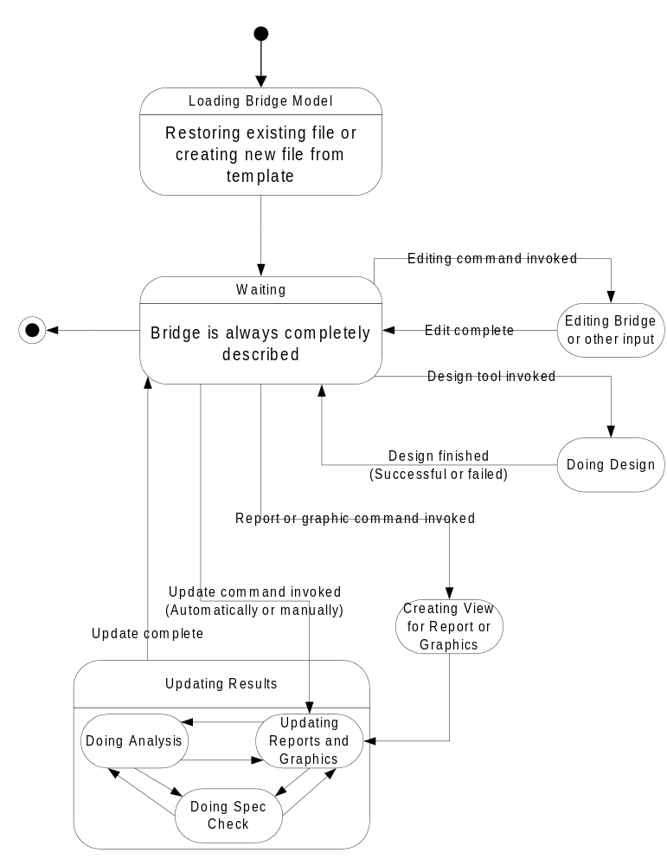
Figure 13

- A detailed specification for the user interface is contained in the document “User Interface Specification for PGSuper”.

